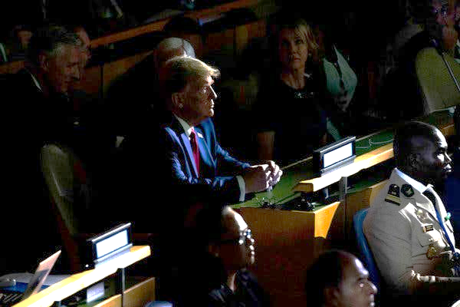
How the Impeachment Process Works

By Charlie Savage
Published Sept. 24, 2019Updated Sept. 26, 2019, 8:00 a.m. ET
The inquiry into President Trump has the potential to reshape his presidency. Here’s how impeachment works.
The Trump administration refused to share a whistleblower complaint, related to Mr. Trump’s communications with Ukraine’s president, with Congress.CreditCreditDoug Mills/The New York Times
WASHINGTON — Speaker Nancy Pelosi announced Tuesday that the House would launch a formal impeachment inquiry in response to the dispute over Mr. Trump’s efforts to pressure Ukraine to investigate his potential 2020 rival, former Vice President Joseph R. Biden Jr.
The rising furor has heightened interest in how the impeachment process works. Here’s what you need to know:

What is impeachment?
The Constitution permits Congress to remove presidents before their term is up if enough lawmakers vote to say that they committed “treason, bribery, or other high crimes and misdemeanors.”
Only two presidents have been impeached — Andrew Johnson in 1868 and Bill Clinton in 1998 — and both were ultimately acquitted and completed their terms in office. Richard M. Nixon resigned in 1974 to avoid being impeached.

What is a “high crime”?
The term “high crimes and misdemeanors” came out of the British common law tradition: it was the sort of offense that Parliament cited in removing crown officials for centuries. Essentially, it means an abuse of power by a high-level public official. This does not necessarily have to be a violation of an ordinary criminal statute
In 1788, as supporters of the Constitution were urging states to ratify the document, Alexander Hamilton described impeachable crimes in one of the Federalist Papers as “those offenses which proceed from the misconduct of public men, or, in other words, from the abuse or violation of some public trust. They are of a nature which may with peculiar propriety be denominated POLITICAL, as they relate chiefly to injuries done immediately to the society itself.”

What is the process?
In both the Nixon and the Clinton cases, the House Judiciary Committee first held an investigation and recommended articles of impeachment to the full House. In theory, however, the House of Representatives could instead set up a special panel to handle the proceedings — or just hold a floor vote on such articles without any committee vetting them
When the full House votes on articles of impeachment, if at least one gets a majority vote, the president is impeached — which is essentially the equivalent of being indicted.

How the Impeachment Process Could Play Out

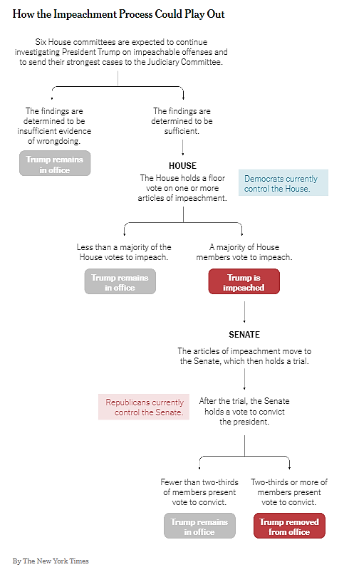

Next, the proceedings move to the Senate, which is to hold a trial overseen by the chief justice of the United States.
A team of lawmakers from the House, known as managers, play the role of prosecutors. The president has defense lawyers, and the Senate serves as the jury.
If at least two-thirds of the senators find the president guilty, he is removed, and the vice president takes over as president. There is no appeal.

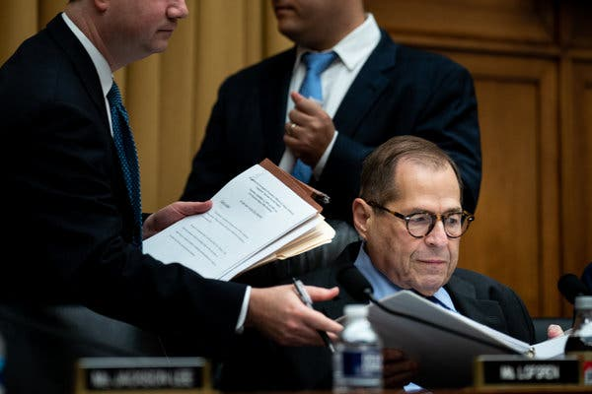
How does a House impeachment inquiry start?

Image
Representative Jerrold Nadler, the chairman of the Judiciary Committee, has claimed that the panel is already engaged in an impeachment investigation.CreditErin Schaff/The New York Times
This has been a subject of dispute. During the Nixon and Clinton impeachment efforts, the full House voted for resolutions directing the House Judiciary Committee to open the inquiries. But it is not clear whether that step is strictly necessary, because impeachment proceedings against other officials, like a former federal judge in 1989, began at the committee level.
The House Judiciary Committee, led by Representative Jerrold Nadler, Democrat of New York, has claimed — including in court filings — that the panel is already engaged in an impeachment investigation. Mr. Trump’s Justice Department has argued that since there has been no House resolution, the committee is just engaged in a routine oversight proceeding.
Ms. Pelosi did not say in her announcement that she intended to bring any resolution to the floor.
Whether or not it is necessary, it has not been clear whether a resolution to formally start an impeachment inquiry would pass a House vote, although the number of Democrats who support one has recently been surging. As of late Tuesday, The New York Times counted 203 members who said they favored impeachment proceedings, 88 who said they opposed them or were undecided, and 144 who had not responded to the question.

What are the rules for a Senate trial?
There are no set rules. Rather, the Senate passes a resolution first laying out trial procedures.
“When the Senate decided what the rules were going to be for our trial, they really made them up as they went along,” Gregory B. Craig, who helped defend Mr. Clinton in his impeachment proceeding and later served as White House counsel to President Barack Obama, told The Times in 2017.
For example, Mr. Craig said, the initial rules in that case gave Republican managers four days to make a case for conviction, followed by four days for the president’s legal team to defend him. These were essentially opening statements. The Senate then decided whether to hear witnesses, and if so, whether it would be live or on videotape. Eventually, the Senate permitted each side to depose several witnesses by videotape.
The rules adopted by the Senate in the Clinton trial — including ones limiting the number of witnesses and the length of depositions — made it harder to prove a case compared with trials in federal court, said former Representative Bob Barr, Republican of Georgia who served as a House manager during the trial and is also a former United States attorney.
“Impeachment is a creature unto itself,” Mr. Barr said. “The jury in a criminal case doesn’t set the rules for a case and can’t decide what evidence they want to see and what they won’t.”

What are the standards for impeachment and removal?
The Constitution does not specify many, making impeachment and removal as much a question of political will as of legal analysis.
For example, the Constitution does not detail how lawmakers may choose to interpret what does or does not constitute impeachable “treason, bribery, or other high crimes and misdemeanors.” Similarly, there is no established standard of proof that must be met.

Is the Senate obligated to hold a trial?
The Constitution clearly envisions that if the House impeaches a federal official, the next step is for the Senate to hold a trial. But there is no obvious enforcement mechanism if Senator Mitch McConnell, Republican of Kentucky and the majority leader, were to simply refuse to convene one — just as he refused to permit a confirmation hearing and vote on Mr. Obama’s nominee, Judge Merrick Garland, to fill a Supreme Court vacancy in 2016.
Still Walter Dellinger, a Duke University law professor and a former acting solicitor general in the Clinton administration, said it is unclear whether it would be Mr. McConnell or Chief Justice John G. Roberts Jr. who wields the authority to convene the Senate for the purpose of considering House-passed articles of impeachment.
Either way, though, he noted that the Republican majority in the Senate could vote to immediately dismiss the case without any consideration of the evidence if it wanted.
To date, Senate Republicans have given no indication that they would break with Mr. Trump, especially in numbers sufficient to remove him from office. In their internal debate about what to do, some Democrats have argued that this political reality means that they should instead focus on trying to beat him in the 2020 election, on the theory that an acquittal in the Senate might backfire by strengthening him politically. Others have argued that impeaching him is a moral necessity to deter future presidents from acting like Mr. Trump, even if Senate Republicans are likely to keep him in office.
In that same Federalist Paper written in 1788, Mr. Hamilton wrote that the inherently political nature of impeachment proceedings would be sure to polarize the country.
Their prosecution, he wrote, “will seldom fail to agitate the passions of the whole community, and to divide it into parties more or less friendly or inimical to the accused. In many cases it will connect itself with the pre-existing factions, and will enlist all their animosities, partialities, influence and interest on one side or on the other; and in such cases there will always be the greatest danger that the decision will be regulated more by the comparative strength of parties, than by the real demonstrations of innocence or guilt.”

Source: https://www.nytimes.com/2019/09/24/us/politics/impeachment-trump-explained.html?utm_source=pocket-newtab

