● The links with the answers are provided prior to each question. ● Sections/words/phrases within each page are in quotes when an exact place is needed to answer the question. ● The general answers are in gray following the questions; the most essential answer to the question is bolded in the gray area. ● You could do this as a class together, or even better, assign it for homework (And a TA could grade these – just circle a few of the questions you are most concerned with for your students, then have a TA focus on these. These answers should not just be a check off…).

UNIVERSITY OF WISCONSIN - MADISON

http://writing.wisc.edu/Handbook/QPA_plagiarism.html
1. What is “general common knowledge”?
General common knowledge is factual information considered to be in the public domain, such as birth and death dates of well-known figures, and generally accepted dates of military, political, literary, and other historical events. In general, factual information contained in multiple standard reference works can usually be considered to be in the public domain.

2. What is “field-specific common knowledge”?
Field-specific common knowledge is "common" only within a particular field or specialty. It may include facts, theories, or methods that are familiar to readers within that discipline. For instance, you may not need to cite a reference to Piaget’s developmental stages in a paper for an education class or give a source for your description of a commonly used method in a biology report - but you must be sure that this information is so widely known within that field that it will be shared by your readers.

3. What do you do if you are not sure if it is general/field-specific common knowledge?
If in doubt, be cautious and cite the source. And in the case of both general and field-specific common knowledge, if you use the exact words of the reference source, you must use quotation marks and credit the source.

http://writing.wisc.edu/Handbook/QPA_PorQ.html
4. Under the “In research papers” section, the last bullet point is key; what does it say about when you should use direct quotes?
- to present a particularly well-stated passage whose meaning would be lost or changed if paraphrased or summarized

5. And what is the general answer about if you should quote or paraphrase?
In general, use direct quotations only if you have a good reason. Most of your paper should be in your own words.

http://writing.wisc.edu/Handbook/QPA_paraphrase.html
6. Under the “Word-for-Word Plagiarism” example, read the example and read “Why this is plagiarism” just read below the passage. Aside from not giving the source of information acknowledgement, what else has the writer done that shares that this piece is not their own work? Notice that the writer has not only “borrowed” Chase’s material (the results of her research) with no acknowledgment, but has also largely maintained the author’s method of expression and sentence structure. The phrases in red are directly copied from the source or changed only slightly in form.

7. Under the “A Patchwork Paraphrase” example, why is this plagiarism? Read “Why this is plagiarism” to find the answer.
This paraphrase is a patchwork composed of pieces in the original author’s language (in red) and pieces in the student-writer’s words, all rearranged into a new pattern, but with none of the borrowed pieces in quotation marks. Thus, even though the writer acknowledges the source of the material, the underlined (red) phrases are falsely presented as the student’s own.

http://writing.wisc.edu/Handbook/QPA_paraphrase2.html
8. What are the two suggested “Methods of Paraphrasing”?
1. Look away from the source; then write.
2. Take notes.

9. What is probably the situation if you cannot do either 1. or 2.?
If you find that you can't do 1. or 2, this may mean that you don't understand the passage completely or that you need to use a more structured process until you have more experience in paraphrasing.

http://writing.wisc.edu/Handbook/QPA_quoting.html
10. Generally, what two elements are involved in integrating a direct quote into your writing?
A signal that a quotation is coming--generally the author's name and/or a reference to the work
An assertion that indicates the relationship of the quotation to your text

PURDUE UNIVERSITY

http://owl.english.purdue.edu/owl/resource/589/01/
11. Look at this contradictions chart, which ‘contradiction’ has been most difficult for you to do or understand? Why?

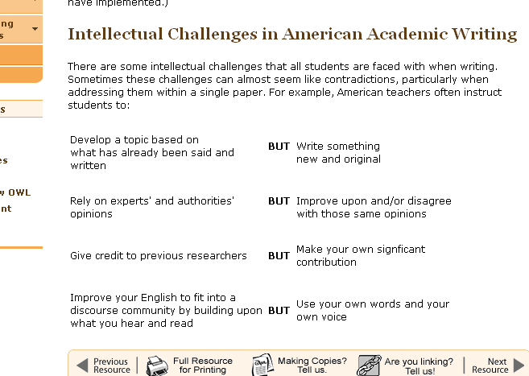

http://owl.english.purdue.edu/owl/resource/589/02/
12. Under “When Do We Give Credit?” briefly summarize when citations are needed.
- Words or ideas presented in a magazine, book, newspaper, song, TV program, movie, Web page, computer program, letter, advertisement, or any other medium
- Information you gain through interviewing or conversing with another person, face to face, over the phone, or in writing
- When you copy the exact words or a unique phrase
- When you reprint any diagrams, illustrations, charts, pictures, or other visual materials
- When you reuse or repost any electronically-available media, including images, audio, video, or other media
Bottom line, document any words, ideas, or other productions that originate somewhere outside of you.
13. List three occasions where you do NOT need to cite your information.
- Writing your own lived experiences, your own observations and insights, your own thoughts, and your own conclusions about a subject
- When you are writing up your own results obtained through lab or field experiments
- When you use your own artwork, digital photographs, video, audio, etc.
- When you are using "common knowledge," things like folklore, common sense observations, myths, urban legends, and historical events
- When you are using generally-accepted facts, e.g., pollution is bad for the environment, including facts that are accepted within particular discourse communities, e.g., in the field of composition studies, "writing is a process" is a generally-accepted fact.
http://owl.english.purdue.edu/owl/resource/589/03/
14. Read through the “Safe Practices” page and write down at least two things that stand out to you.

Answers will vary – here is a list of the sub-topics:
- Reading and Note-Taking
- Interviewing and Conversing
- Writing Paraphrases or Summaries
- Writing Direct Quotations
- Writing About Another's Ideas
- Maintaining Drafts of Your Paper
- Revising, Proofreading, and Finalizing Your Paper
NORTHWESTERN UNIVERSITY

http://www.writing.northwestern.edu/avoiding_plagiarism.html
15. Under the heading “What is plagiarism, and why…”, there are two types of plagiarism explained. What are they?
Deliberate plagiarism is cheating. Deliberate plagiarism is copying the work of others and turning it as your own. Whether you copy from a published essay, an encyclopedia article, or a paper from a fraternity's files, you are plagiarizing. If you do so, you run a terrible risk. You could be punished, suspended, or even expelled.
But there is also another kind of plagiarism--accidental plagiarism. This happens when a writer does not intend to plagiarize, but fails to cite his or her sources completely and correctly. Careful notetaking and a clear understanding of the rules for quoting, paraphraing, and summarizing sources can help prevent this.
16. What is the first tip under the heading: “Some tips for avoiding accidental plagiarism…”?
Cite every piece of information that is not a) the result of your own research, or b) common knowledge. This includes opinions, arguments, and speculations as well as facts, details, figures, and statistics.

17. Under the “Applying these tips…” section, read through tip 1 but focus on Tip 2, “Misplaced Citations”. What is one reason that note-taking is so important?
If you use a paraphrase or direct quotation, it is important to place the reference at the very end of all the material cited. Any quoted, paraphrased, or summarized material that comes after the reference is plagiarized: it looks like it is supposed to be your own idea.
This is one reason why accurate notetaking is so important; it is possible to forget which words are yours and which are the original writers.
18. Still under Tip 2, why is the “Plagiarism (misplaced citation)” example in red, plagiarism?
The reader would logically assume that the sentence following the citation is your own comment on the quotation, when it is actually part of the original quote.

19. Still under Tip 2, what do you do with multiple citations from the same source?
Finally, a point about multiple citations from the same source: cite them all individually. It is not adequate to give one citation at the end of the paragraph for a bunch of individual points abstracted from a source.

